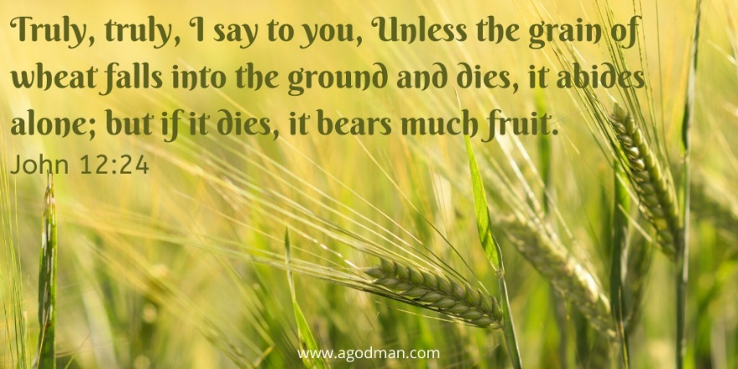
Sunday Worship
March 21, 2021
Draw near to God
for God is waiting for you.

(If you are using a Lenten Cross made of six candles, light all but two candle before beginning the service)
PRELUDE
CALL TO WORSHIP (from Jeremiah 31)
God has promised to make a new covenant with us.
Our Lord has promised to write God’s law on our hearts.
We will no longer teach one another, or say to each other, “Know the Lord,” for we shall all know God.
For God will forgive our iniquity and remember our sin no more.
May we remember this promise as we journey towards the cross!
OPENING PRAYER
Gracious God, we pray that you would be with us this day as we take our fifth step in this Lenten journey, the step of sacrifice. May we, like Jesus, be willing to give our lives wholly to You! Amen.
HYMN #264 “At the Name of Jesus” 1. At the name of Jesus every knee shall bow, every tongue confess him King of glory now; 'tis the Father's pleasure we should call him Lord, who from the beginning was the mighty Word.
2 Humbled for a season to receive a name from the lips of sinners unto whom he came, faithfully he bore it spotless to the last, brought it back victorious, when from death he passed.
3. Bore it up triumphant with its human light, through all ranks of creatures to the central height;
to the throne of Godhead, to the Father’s breast, filled it with the glory of that perfect rest.
4. Christians, this Lord Jesus shall return again, with his Father's glory o’er the earth to rein; for all wreaths of empire meet upon his brow, and our hearts confess him King of glory now.

LENTEN CROSS CONFESSIONAL LITANY – The Silver Coins
(Extinguish one more candle before using the following liturgy)
Leader: We lay before the cross today the bag of silver coins, payment given for betrayal of our Lord. Judas handed Jesus over to the authorities, hoping finally to force Jesus to demonstrate His power. The mission of Judas succeeded but in a way he did not expect and could not bear.
People: Lord Jesus, it is easier to be unfaithful to You than to give up our desire for earthly power. Help us say “no” to our quest for this world’s kingdoms. Help us say “yes” to the cross.
Leader: Judas pushed Jesus to bring a kingdom of earthly power, with swords and conquests. Jesus established the Kingdom instead in humility and service, with forgiveness, and with sacrifice. God’s Kingdom came, strangely enough, not through the shedding of enemy blood, but through the shed blood of its Ruler.
People: Lord Jesus, when we are tempted to reshape the Kingdom of God for our own prestige, profit, or power, help us say “no” to the thirty pieces of silver. Help us say “yes” to the cross.
Leader: Judas wanted a king to take away his country’s suffering. He received a High Priest who chooses to participate in those sufferings.
People: Lord Jesus, the world seeks a life free from suffering. You lived a life made perfect in suffering. Help us say “no” to the way of the world. Help us say “yes” to the way of the cross.
Leader: Let us pray together…
All: Almighty God, you allowed Your Son to be perfected through suffering. Remind us today of our High Priest who meets us in our suffering. In our sufferings, teach us obedience; mold us into His image, we pray. Amen.
FIRST SCRIPTURE LESSON Jeremiah 31:31-34 31 The days are surely coming, says the Lord, when I will make a new covenant with the house of Israel and the house of Judah. 32 It will not be like the covenant that I made with their ancestors when I took them by the hand to bring them out of the land of Egypt—a covenant that they broke, though I was their husband, says the Lord. 33 But this is the covenant that I will make with the house of Israel after those days, says the Lord: I will put my law within them, and I will write it on their hearts; and I will be their God, and they shall be my people. 34 No longer shall they teach one another, or say to each other, “Know the Lord,” for they shall all know me, from the least of them to the greatest, says the Lord; for I will forgive their iniquity, and remember their sin no more.
TIME WITH THE CHILDREN
HYMN “Man of Sorrows, What a Name” 1. Man of sorrows what a name for the Son of God who came, ruined sinners to reclaim: Hallelujah, what a Savior! 2. Bearing shame and scoffing rude, in my place condemned he stood, sealed my pardon with his blood: Hallelujah, what a Savior! 3. Guilty, vile, and helpless we; spotless Lamb of God was he. Full atonement! Can it be?: Hallelujah, what a Savior! 4. lifted up was He to die; "It is finished" was His cry; now in heaven exalted high: Hallelujah, what a Savior! 5. When he comes, our glorious King, all his ransomed home to bring, then anew this song we'll sing: Hallelujah, Hallelujah what a Savior!
SECOND SCRIPTURE LESSON John 12:20-33 20 Now among those who went up to worship at the festival were some Greeks. 21 They came to Philip, who was from Bethsaida in Galilee, and said to him, “Sir, we wish to see Jesus.” 22 Philip went and told Andrew; then Andrew and Philip went and told Jesus. 23 Jesus answered them, “The hour has come for the Son of Man to be glorified. 24 Very truly, I tell you, unless a grain of wheat falls into the earth and dies, it remains just a single grain; but if it dies, it bears much fruit. 25 Those who love their life lose it, and those who hate their life in this world will keep it for eternal life. 26 Whoever serves me must follow me, and where I am, there will my servant be also. Whoever serves me, the Father will honor.
27 “Now my soul is troubled. And what should I say—‘Father, save me from this hour’? No, it is for this reason that I have come to this hour. 28 Father, glorify your name.” Then a voice came from heaven, “I have glorified it, and I will glorify it again.” 29 The crowd standing there heard it and said that it was thunder. Others said, “An angel has spoken to him.” 30 Jesus answered, “This voice has come for your sake, not for mine. 31 Now is the judgment of this world; now the ruler of this world will be driven out. 32 And I, when I am lifted up from the earth, will draw all people to myself.” 33 He said this to indicate the kind of death he was to die.
SERMON “The Hour Has Come” Pastor Susan Faye Wonderland
RECOGNITION OF THE OFFERING AND PRAYER OF DEDICATION Glorious God, you sent Jesus to change our lives in bold and amazing ways. Yet, we often are consumed by the pettiness of our own “to do” lists. As we place this offering before you, help us to surrender completely to your love and to be stirred into fruit-bearing action that results in faithful stewardship. In your holy name, we pray. Amen
JOYS AND CONCERNS
PRAYERS OF INTERCESSION AND THE LORD’S PRAYER
Our Father who art in heaven, hallowed be thy name. Thy kingdom come, thy will be done, on earth as it is in heaven. Give us this day our daily bread; and forgive us our debts, as we forgive our debtors; and lead us not into temptation, but deliver us from evil. For thine is the kingdom and the power and the glory, forever. Amen
HYMN #792 “There is a Balm in Gilead” Refrain: There is a balm in Gilead to make the wounded whole, there is a balm in Gilead to heal the sin-sick soul. 1. Sometimes I feel discouraged and think my work's in vain, but then the Holy Spirit revives my soul again. Refrain 3. If you can’t preach like Peter, if you can’t pray like Paul, just tell the love of Jesus and say, "He died for all." Refrain
BENEDICTION
God has forgiven us and established a new covenant with us in Jesus Christ. In Christ, God has written God’s law on our hearts. May we go from here as a witness to the new covenant of peace and justice for all. Let us lift up the brokenhearted and stand with the oppressed. And let everything we do be out of the love of God in Christ. Amen.
POSTLUDE

Sunday March 21th – ANNOUNCEMENTS
SUNDAY SCHOOL TODAY - Join us today for Sunday school class for all ages at 11:30am on Zoom: https://zoom.us/j/127591875. For one half hour our children will be hearing stories, singing songs, engaging in activities and games about God and God’s teachings.

THURSDAY EVENING STUDY AND FELLOWSHIP: Join us this Thursday evening March 25, 2021 at 7pm on Zoom https://zoom.us/j/127591875 Meeting ID: 127 591 875 or by phone: 301-715-8592 or 253-215-8782. This week our seminary intern Ryon Herin will guide us through “Visitation and Volunteering”; Through the Holy Spirit and Scripture, we will journey together in exploring how to use each of our unique gifts in caring for each other and our wider community.

WEEKLY LENTEN COMMUNION SERVICES: Wednesday March 24rd, we will be gathering for a brief meditation, prayer, and share communion at 8:30am on Zoom https://zoom.us/j/127591875

PRAYER WALL: Having a Prayer Wall at the church allows not only church members to request and pray for each other, but also brings in the community who might not know how or where to pray but appreciate the prayers of others. All are invited to write out their prayer on a strip of fabric that is found in a plastic bin next to the “wall” and tie it to the chicken wire. All are also invited to stop by, read the prayers and offer them up to the Lord.
PALMS FOR PALM SUNDAY: Palms for Palm Sunday will be available for pick up Thursday March 25 at the rear entrance of the church.

EASTER FELLOWSHIP ACTIVITY: On Sunday, March 28 at 3:00 we will gather on Zoom: https://zoom.us/j/127591875 Meeting ID: 127 591 875 or by phone: 301-715-8592 or 253-215-8782 to dye Easter Eggs and/or hats as well as learn how to make Ukrainian Easter Eggs. Even if you haven’t dyed eggs in years, why not hard boil up a few and get creative with us.? Please provide your own supplies. It will be a fun time of sharing.
Calendar:
March 23 - 7PM Sessions - Zoom
March 24 - 8:30AM Lenten Communion Service - Zoom
6:00 PM Confirmation Class
March 25 - 7 PM Thursday evening Study and Fellowship - Zoom

In our thoughts and prayers: Su Fall, The Conner/Lang Family, Diane Dauer,
Aleena Lang, Natalie Pizza, Bill Wark, Nancy Yerkes, Raymond Tinari, Dick Wright
Easter Plants
For a donation of $10 per plant you can help
Brighten up our Altar for Easter.
Name:_________________________________________

In Memory/Honor of:____________________________________

____ I wish to take a Plant after the Easter Service. ___Lily, ___Gerber Daisy, ___Hyacinth, ___Tulip
____Please, deliver to a shut-in or someone in the hospital (complete information below)

Name:
Address:
Phone Number:
Donations will be accepted no later than March 29th. Pls. Drop off or Mail to: Forest Grove Presbyterian Church, P.O. Box 1856 Forest Grove, Pa 18922

